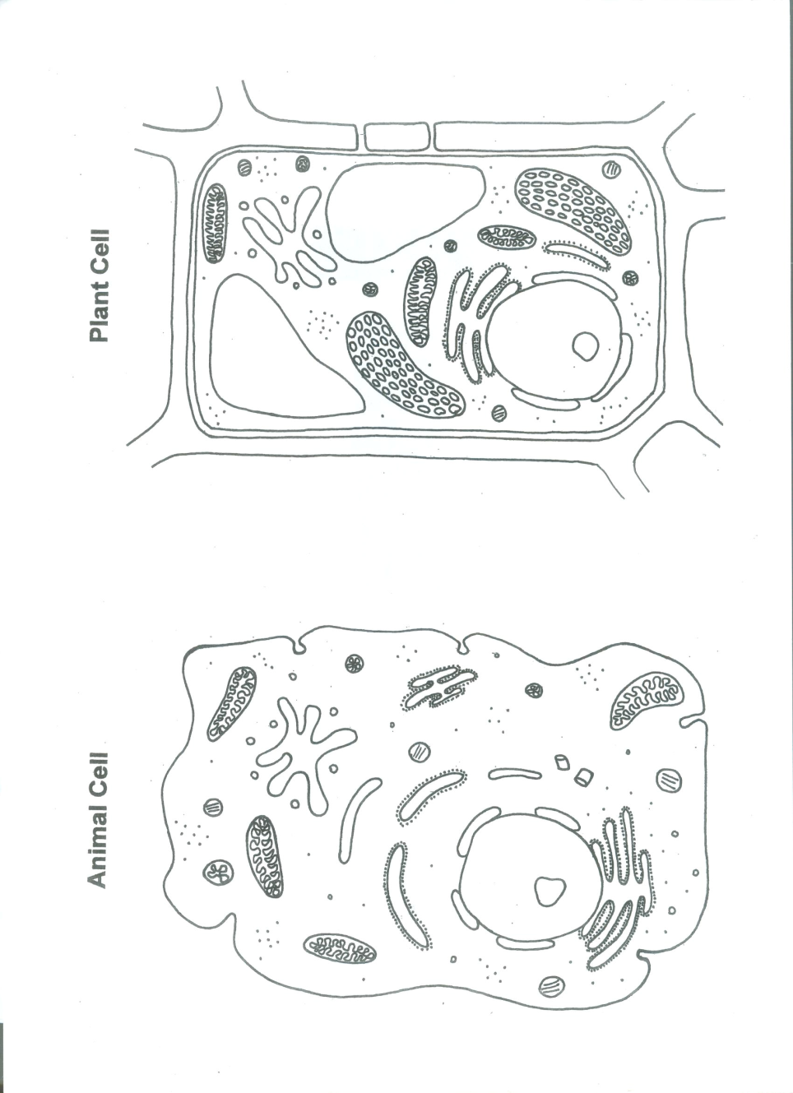
Name: ________________________________________ Date: _________________________ Per: _________

Cell and Cell Transport Review

Part 1: label the cells and organelles in the images below

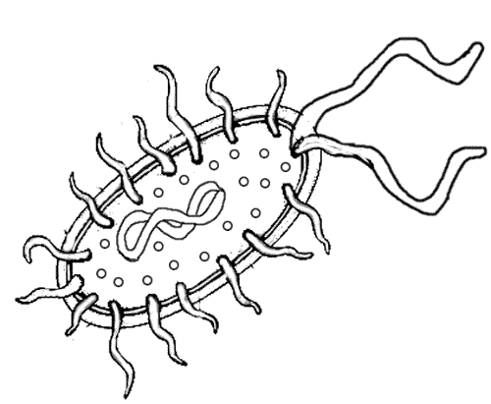

Part 2: List the function of the organelles that you labeled above and tell what organ in the human body would have a similar function

Organelle | Function | Human body analogy
Nucleus |  | Brain
Ribosome
Mitochondria
Cell membrane
Flagella
* Cell wall
Cytoplasm
Vacuole
* Chloroplast
Golgi apparatus
Lysosome
Endoplasmic Reticulum

* = organelles that are found only in ___________________________________________________________

Part 3: In the chart below, check the appropriate box with an “X” if it has the structure. Some may have more than one “X”

Cell Features | Prokaryotic Cell | Eukaryotic Cell
Has a nucleus and other membrane bound organelles
Has a cell membrane
Includes bacteria
Includes plant cells
Includes animal cells
Is unicellular
Is multicellular

Part 4: Fill in the chart below for active and passive transport

Type of Transport | Movement of molecules | Energy requirements | Process
1.

2.

3. Facilitated diffusion
1.

2. Exocytosis

Part 5: match each term in column A with its meaning in column B. Write the letters on the line

Column A Column B

________ 1. Diffusion A. Makes protein

________ 2. Selectively permeable B. Converts sunlight into chemical energy

________ 3. Cell membrane C. Can limit the kinds of molecules that pass through

________ 4. Phospholipid D. When substances, in a vesicle, are discharged from cell

________ 5. Isotonic E. type of endocytosis where a cell engulfs a solid particle

________ 6. Hypertonic F. The movement of molecules from an area of high concentration to low concentration

________ 7. Hypotonic G. Makes up the cell membrane

________ 8. Mitochondria H. Equal concentration inside and outside the cell

________ 9. Chloroplast I. Movement of water inside a cell, causes cell to swell

________ 10. Flagella J. Type of endocytosis where a cell engulfs fluids

________ 11. Cilia K. Whip-like tail used for movement

________ 12. Ribosome L. Movement of water from areas of high concentration to areas of low concentration

________ 13. Phagocytosis M. Controls the cells activities

________ 14. Osmosis N. Movement of water outside a cell, causes cell to shrink

________ 15. Pinocytosis O. Tiny hairs used for movement

________ 16. Exocytosis P. Controls what goes in and out of a cell

_________ 17. Endocytosis Q. When a cell takes substances inside by enclosing them by the membrane

